**MUTATION:**

In biology, a mutation is the permanent alteration of the nucleotide sequence of the genome of an organism, virus, or extrachromosomal DNA or other genetic elements.

Mutations result from errors during DNA replication or other types of damage to DNA, which then may undergo error-prone repair (especially microhomology-mediated end joining), or cause an error during other forms of repair, or else may cause an error during replication (translesion synthesis). Mutations may also result from insertion or deletion of segments of DNA due to mobile genetic elements. Mutations may or may not produce discernible changes in the observable characteristics (phenotype) of an organism. Mutations play a part in both normal and abnormal biological processes including: evolution, cancer, and the development of the immune system, including junctional diversity.

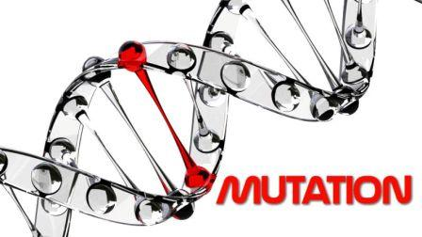

**History of Mutation:**

The word "mutation" means something different to a comic book enthusiast than it does to a genetic researcher. But even as it pertains to science, the idea of mutation has meant different things over time, changing greatly from how Darwin perceived it to how it is used in the context of the genome.

It is this evolution of the concept of mutation that drives Elof Axel Carlson's new book, *Mutation: The History of an Idea from Darwin to Genomics*. Carlson, a professor emeritus at the State University of New York at Stony Brook, says most geneticists today conceptualize 'mutation' as a change in an individual gene — an idea that dates back to the work of Nobel laureate Hermann Joseph Muller in the 1920s. But that is not how it always was. The term mutation itself has mutated and evolved to suit what researchers have learned since the time of Darwin.

Beginning with Darwin and pre-Mendelian ideas of what mutation was, continuing through the Mendelian aspects, work done by Thomas Hunt Morgan with fruit flies, and continuing through to the ideas of mutagenesis, biochemical approaches to the study of mutation, and mutation in relation to evolution, Carlson admirably straddles the very fine line between losing the reader in overly detailed explanations or by being so vague as to say nothing at all.

**Harmful Mutations:**

Changes in DNA caused by mutation can cause errors in protein sequence, creating partially or completely non-functional proteins. Each cell, in order to function correctly, depends on thousands of proteins to function in the right places at the right times. When a mutation alters a protein that plays a critical role in the body, a medical condition can result. Some mutations alter a gene's DNA base sequence but do not change the function of the protein made by the gene. One study on the comparison of genes between different species of Drosophila suggests that if a mutation does change a protein, this will probably be harmful, with an estimated 70 percent of amino acid polymorphisms having damaging effects, and the remainder being either neutral or weakly beneficial. Studies have shown that only 7% of point mutations in noncoding DNA of yeast are deleterious and 12% in coding DNA are deleterious. The rest of the mutations are either neutral or slightly beneficial.

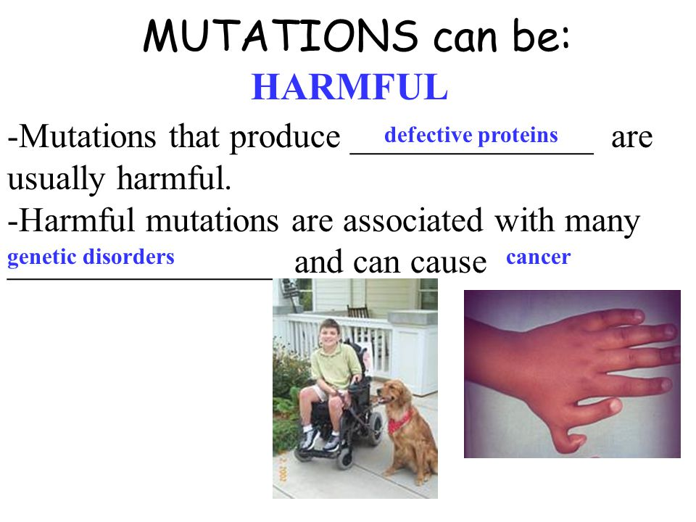

If a mutation is present in a germ cell, it can give rise to offspring that carries the mutation in all of its cells. This is the case in hereditary diseases. In particular, if there is a mutation in a DNA repair gene within a germ cell, humans carrying such germline mutations may have an increased risk of cancer. A list of 34 such germline mutations is given in the article DNA repair-deficiency disorder. An example of one is albinism, a mutation that occurs in the OCA1 or OCA2 gene. Individuals with this disorder are more prone to many types of cancers, other disorders and have impaired vision. On the other hand, a mutation may occur in a somatic cell of an organism. Such mutations will be present in all descendants of this cell within the same organism, and certain mutations can cause the cell to become malignant, and, thus, cause cancer.

A DNA damage can cause an error when the DNA is replicated, and this error of replication can cause a gene mutation that, in turn, could cause a genetic disorder. DNA damages are repaired by the DNA repair system of the cell. Each cell has a number of pathways through which enzymes recognize and repair damages in DNA. Because DNA can be damaged in many ways, the process of DNA repair is an important way in which the body protects itself from disease. Once DNA damage has given rise to a mutation, the mutation cannot be repaired. DNA repair pathways can only recognize and act on "abnormal" structures in the DNA. Once a mutation occurs in a gene sequence it then has normal DNA structure and cannot be repaired.

**Beneficial Mutations:**

Although mutations that cause changes in protein sequences can be harmful to an organism, on occasions the effect may be positive in a given environment. In this case, the mutation may enable the mutant organism to withstand particular environmental stresses better than wild-type organisms, or reproduce more quickly. In these cases a mutation will tend to become more common in a population through natural selection.

For example, a specific 32 base pair deletion in human CCR5 (CCR5-Δ32) confers HIV resistance to homozygotes and delays AIDS onset in heterozygotes.[86] One possible explanation of the etiology of the relatively high frequency of CCR5-Δ32 in the European population is that it conferred resistance to the bubonic plague in mid-14th century Europe. People with this mutation were more likely to survive infection; thus its frequency in the population increased. This theory could explain why this mutation is not found in Southern Africa, which remained untouched by bubonic plague. A newer theory suggests that the selective pressure on the CCR5 Delta 32 mutation was caused by smallpox instead of the bubonic plague.

An example of a harmful mutation is sickle-cell disease, a blood disorder in which the body produces an abnormal type of the oxygen-carrying substance hemoglobin in the red blood cells. One-third of all indigenous inhabitants of Sub-Saharan Africa carry the gene, because, in areas where malaria is common, there is a survival value in carrying only a single sickle-cell gene (sickle cell trait). Those with only one of the two alleles of the sickle-cell disease are more resistant to malaria, since the infestation of the malaria Plasmodium is halted by the sickling of the cells that it infests.

